Comprehensive SOP for Deploying Loki on OpenShift Container Platform

Executive summary
This report provides a rigorous, end-to-end Standard Operating Procedure for the Loki deployment pattern that was validated during the 25 June 2026 migration session on OpenShift Container Platform. It is written as a Word-document-ready operating standard in en-GB and is intended to become the canonical internal runbook for future repeat deployments, audits, troubleshooting, and rollback planning. The report uses official Red Hat OpenShift Logging, Loki Operator, and Cluster Observability Operator documentation as the primary sources, with Grafana Loki component documentation used to explain the internal read and write paths. It also incorporates the commands, patches, and operational lessons from the worked session as implementation examples. [1]
The validated target architecture follows the OpenShift Logging 6 model. In this model, the Red Hat OpenShift Logging Operator manages collection and forwarding, the Loki Operator manages log storage through the LokiStack resource, and the Cluster Observability Operator provides the OpenShift Console logging experience by means of a UIPlugin. Red Hat explicitly documents that Logging 6 replaces Elasticsearch with Loki, replaces Kibana with the Cluster Observability Operator UI plugin, and uses Vector as the supported collector. [2]
In the worked session, the deployment reached a stable end-state only after several corrective actions. The major issues encountered were: Cluster Observability Operator pods remaining Pending because of CPU shortage and infra taints; Loki ingesters failing to schedule because of worker CPU pressure and then infra memory pressure; collector TLS failures against the Loki gateway due to an untrusted service CA; a ClusterLogForwarder schema mistake caused by placing tls under lokiStack instead of under outputs[]; immutable selector conflicts on the operator-managed collector DaemonSet; and Loki-side write failures caused by rate limiting and stale timestamps when forwarding audit and infrastructure logs. The final validated path that exposed logs successfully in Observe > Logs was an application-only ClusterLogForwarder pipeline. That operational choice is consistent with Red Hat’s guidance that Loki is optimised as a short-term, fast-troubleshooting store and may require explicit tuning for ingestion bursts and retention. [3]
This SOP therefore distinguishes between a minimum viable validation build and a production-hardened build. The minimum viable build used 1x.demo sizing in the worked session because available node memory was insufficient for the original profile. For production use, Red Hat documents 1x.extra-small, 1x.small, and 1x.medium as supported production sizes, while 1x.demo is explicitly “demo use only”. [4]
The document below is structured so that it can be copied almost verbatim into a .docx SOP, with inline tables, copy-ready YAML, verification commands, and appendices. It also includes exact instructions for generating the Word document from source text by using python-docx, because the requested final deliverable is a document structure and generation method, not a bundled attachment.

Reference architecture and prerequisites
The installed architecture is best understood as a split control-and-data path. On the write path, application containers emit logs to stdout and stderr, the Vector collector taints and tails node log files, the ClusterLogForwarder selects and forwards log streams, the Loki gateway terminates the authenticated request, the distributor validates and rate-limits streams, and ingesters chunk, WAL-buffer, and flush data to object storage. On the read path, the query frontend and queriers retrieve recent data from ingesters and durable data from object storage, using the index gateway to locate chunk references, after which the Cluster Observability Operator logging plugin renders the results in the OpenShift Console. Red Hat’s documentation establishes the OpenShift roles of the three operators, while Grafana’s Loki component reference explains the internal duties of gateways, distributors, ingesters, queriers, the index gateway, and the compactor. [5]
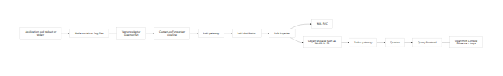
The cluster prerequisites are more stringent than they first appear. Red Hat requires all three operators, cluster-admin permissions, and a supported object store such as AWS S3, MinIO, OpenShift Data Foundation, Azure, GCS, or Swift. The install flow requires the Loki Operator to be configured before the Logging Operator, and Red Hat also states that the Loki and Logging Operators must use the same major and minor version. The worked session demonstrated an additional operational truth not always explicit in installation quickstarts: node roles, taints, and available allocatable CPU and memory are first-order prerequisites, not afterthoughts. Both the Cluster Observability Operator and Loki ingesters remained Pending until node selection and tolerations were aligned with available infra capacity. [6]
The following prerequisite table is suitable for inclusion in the SOP.
Area | Requirement | Why it matters | Worked-session note
Access | cluster-admin and oc CLI | Required for Operators, CRs, RBAC, patching, and verification | Used throughout
Operator stack | Loki Operator, Red Hat OpenShift Logging Operator, Cluster Observability Operator | Storage, collection/forwarding, and UI are distinct operator domains in Logging 6 | All three were required [7]
Object storage | Supported store such as S3, MinIO, ODF, Azure, GCS, or Swift | Loki stores chunks and index data in object storage | MinIO-backed S3-compatible endpoint used in the session [8]
Stateful storage | Valid storageClassName for Loki PVCs | Ingester WAL and local state use PVCs | Session value cluster-specific and therefore unspecified
Capacity | Sufficient CPU and memory on target nodes | Pending pods otherwise block readiness | Session required downsizing and infra placement
Node roles and taints | Planned nodeSelector and tolerations | Loki and COO pods will not schedule across tainted infra nodes unless tolerated | Essential in the worked session [9]
Retention | Loki retention and bucket lifecycle policy | Without retention, logs may remain indefinitely | Must be set before production go-live [10]
Storage horizon | Loki in OpenShift Logging is a short-term store | Red Hat tests and supports short-term storage only, up to 30 days | Important production design limitation [11]
Loki sizing must also be treated explicitly. Red Hat documents the 1x.<size> model and provides quantitative guidance for data transfer, QPS, replication factor, and aggregate resource requests. In the same table, 1x.demo is marked “demo use only”; 1x.pico is defined as minimal-resource HA; and 1x.extra-small, 1x.small, and 1x.medium are the supported production sizes. Red Hat also notes that the replication factor is automatically set to 2 for 1x.extra-small, 1x.small, and 1x.medium. [4]
Loki size/profile | Intended use | Data transfer | QPS target | Replication factor | Total CPU requests | Total memory requests | Total disk requests | Expected node count
1x.demo | Demo only | Demo use only | Demo use only | None | None | None | 40Gi | Unspecified
1x.pico | Minimal-resource HA | 50GB/day | 1–25 QPS at 200ms | 2 | 7 vCPUs | 17Gi | 590Gi | Unspecified
1x.extra-small | Production | 100GB/day | 1–25 QPS at 200ms | 2 | 14 vCPUs | 31Gi | 430Gi | Unspecified
1x.small | Production | 500GB/day | 25–50 QPS at 200ms | 2 | 34 vCPUs | 67Gi | 430Gi | Unspecified
1x.medium | Production | 2TB/day | 25–75 QPS at 200ms | 2 | 54 vCPUs | 139Gi | 590Gi | Unspecified
The “expected node count” column is deliberately marked unspecified because the cited Red Hat table provides aggregate resource requests but does not prescribe a fixed number of nodes. In practice, the required node count depends on allocatable resources, taints, topology strategy, and co-located workloads. [11]

End-to-end procedure
The install order must follow the operator dependency chain. Red Hat states that the Loki Operator must be installed and configured first, followed by the Logging Operator, with the Cluster Observability Operator introduced for visualisation. The migration guidance also makes clear that in Logging 6, visualisation moves away from the old console plugin lifecycle associated with earlier logging releases. [12]
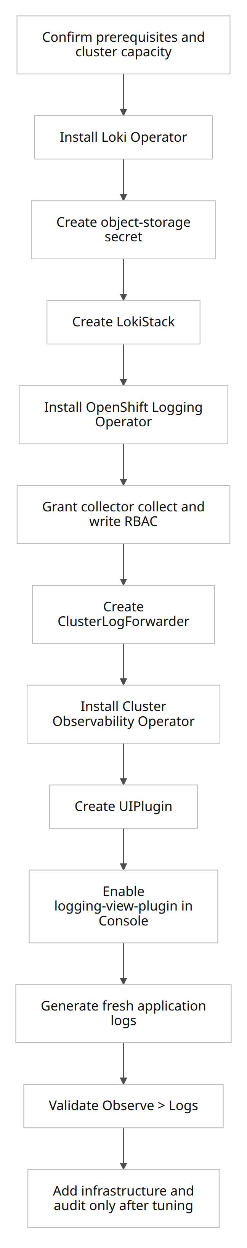

Install the Loki Operator
The install guide places the Loki Operator in openshift-operators-redhat, not openshift-operators, and requires a matching OperatorGroup and Subscription. Red Hat also instructs that the operator channel should be stable-6.<y>, where the exact minor release depends on the deployed Logging/Loki version. [13]
apiVersion: v1
kind: Namespace
metadata:
name: openshift-operators-redhat
labels:
openshift.io/cluster-monitoring: "true"
---
apiVersion: operators.coreos.com/v1
kind: OperatorGroup
metadata:
name: loki-operator
namespace: openshift-operators-redhat
spec:
upgradeStrategy: Default
---
apiVersion: operators.coreos.com/v1alpha1
kind: Subscription
metadata:
name: loki-operator
namespace: openshift-operators-redhat
spec:
channel: stable-6.<y>
installPlanApproval: Automatic
name: loki-operator
source: redhat-operators
sourceNamespace: openshift-marketplace
oc apply -f loki-operator.yaml
oc get subscription -n openshift-operators-redhat
oc get csv -n openshift-operators-redhat

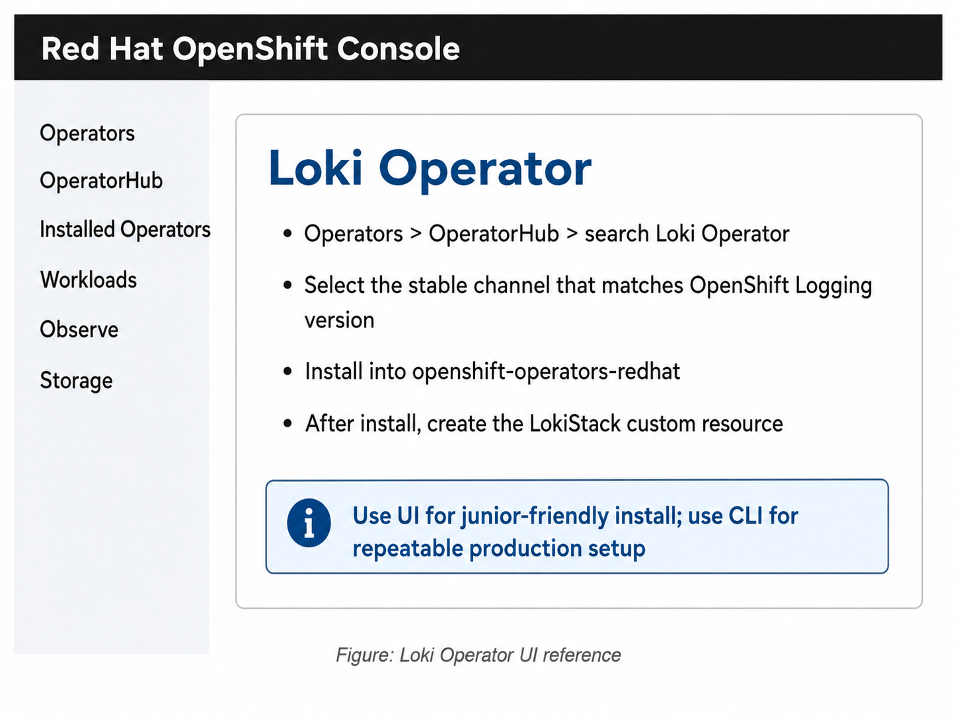
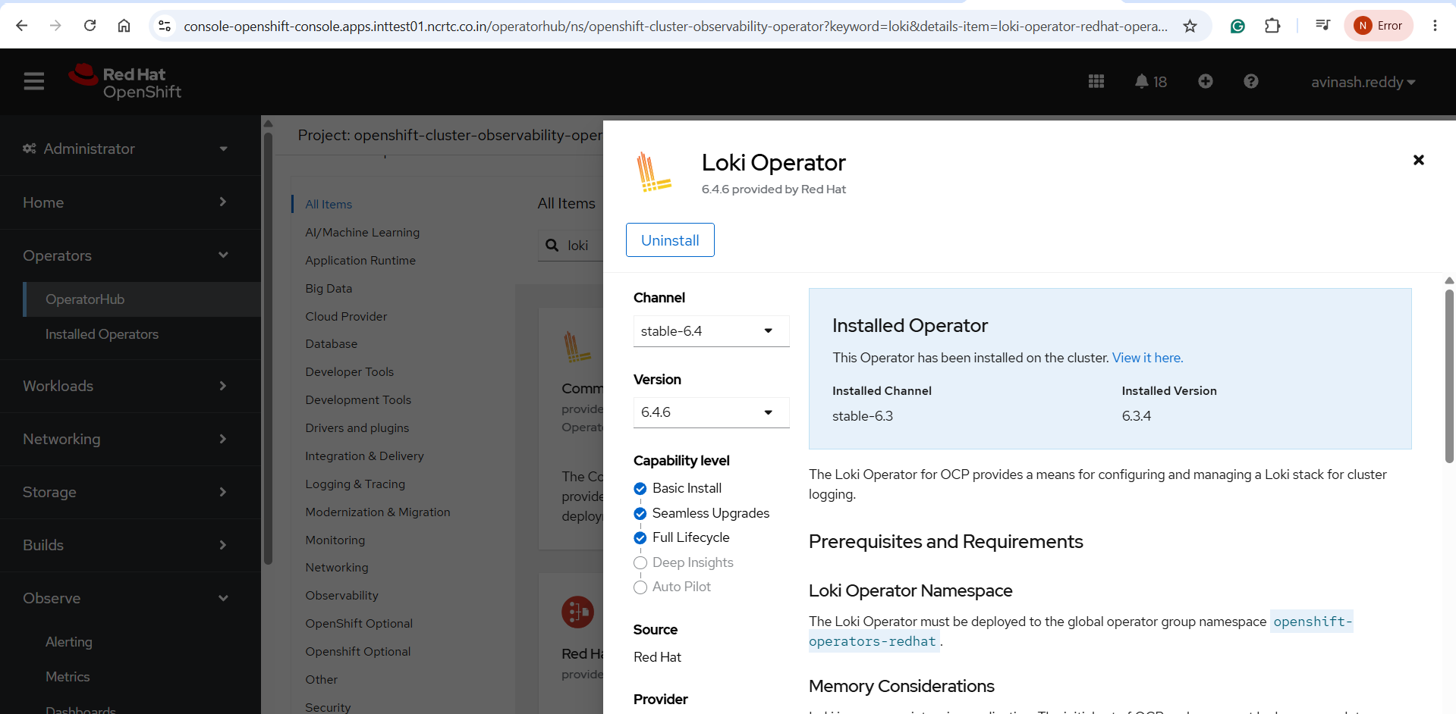

Expected output and check. The Loki Operator subscription should resolve, and the relevant CSV should move to Succeeded. If the CSV does not progress, inspect events and OLM conditions.

Install Cluster Observability Operator from UI
- Go to Operators > OperatorHub.
- Search for Cluster Observability Operator.
- Install the Red Hat operator.
- Wait for all pods under openshift-cluster-observability-operator to become Running.
- This operator is required for the Observe > Logs UI experience.
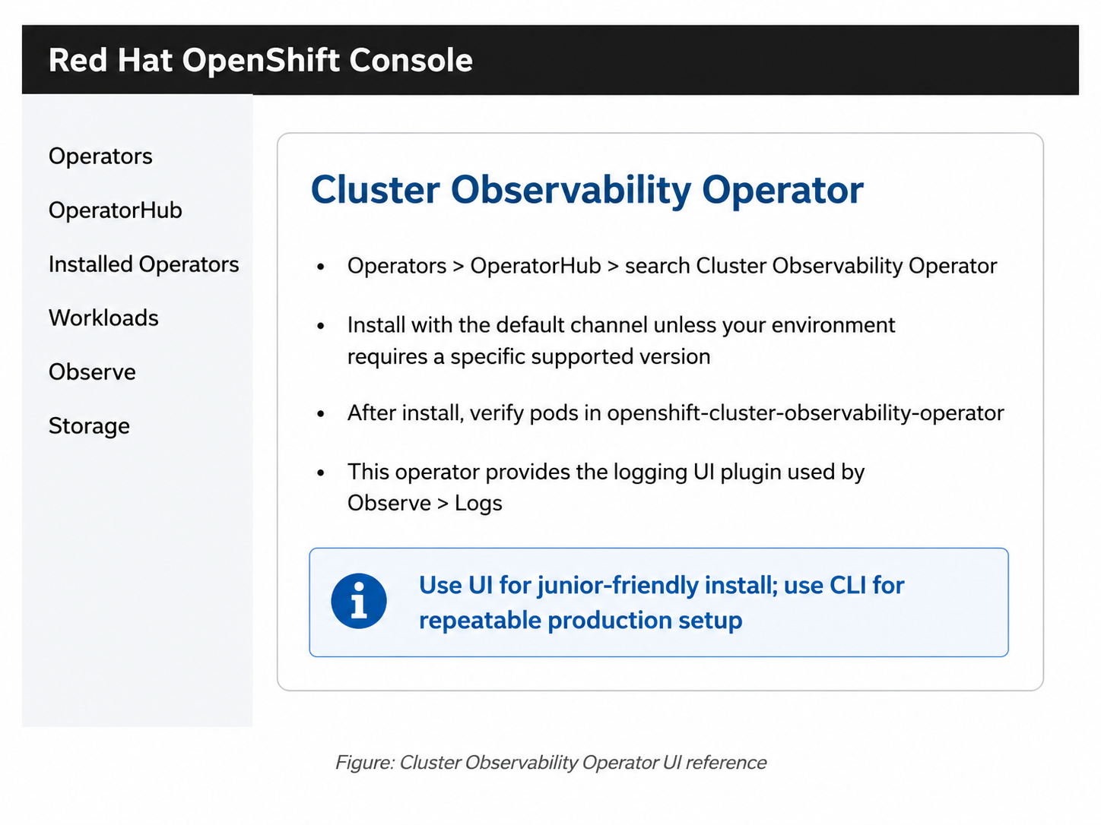
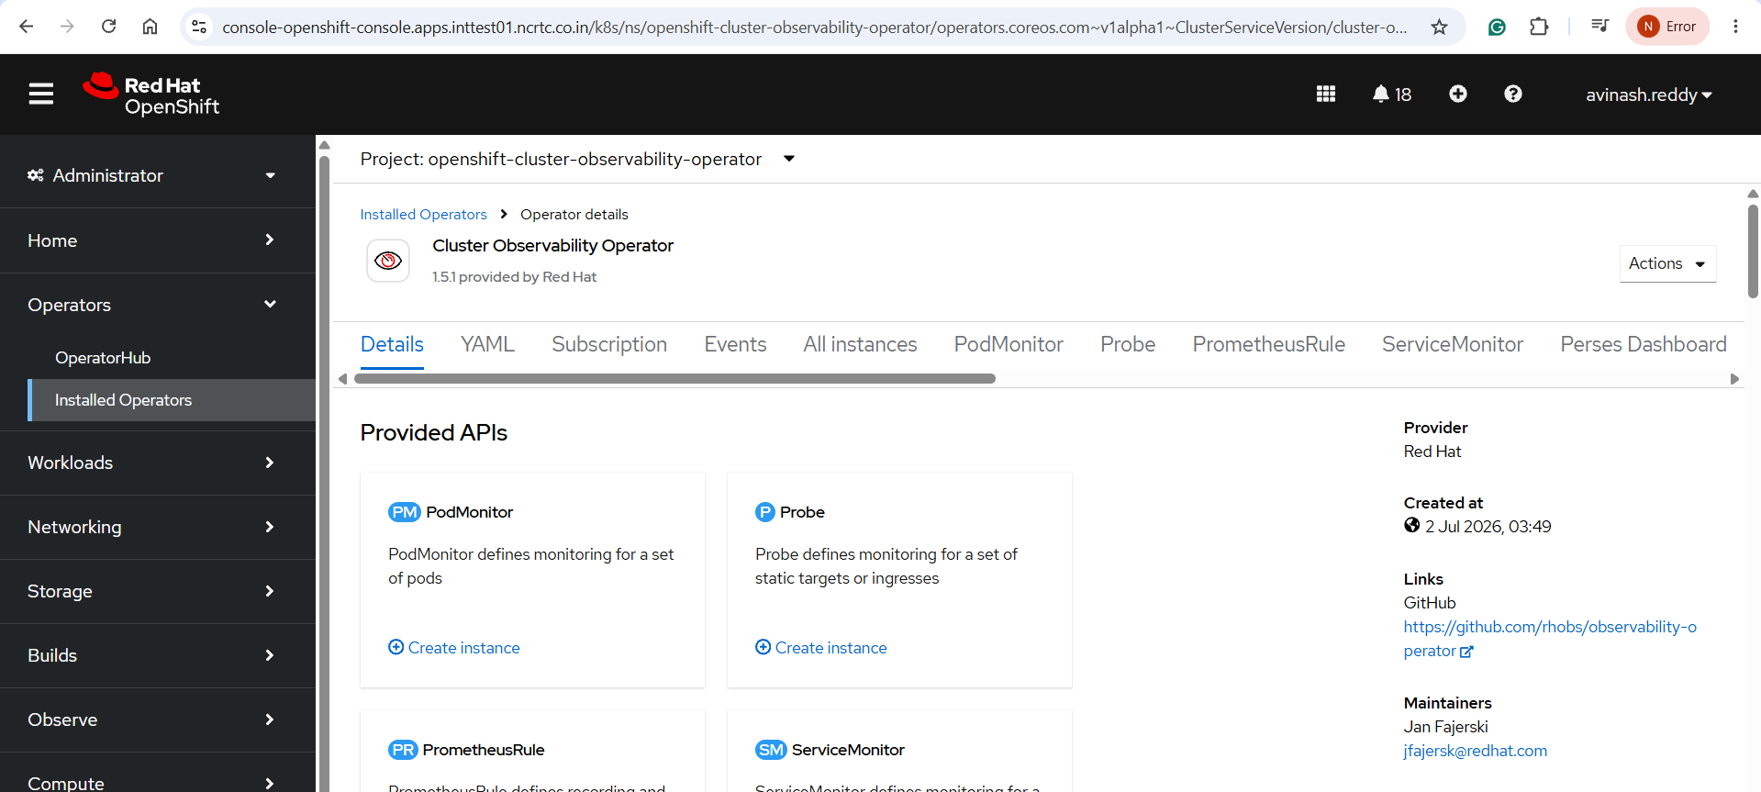
Figure 3: Cluster Observability Operator UI reference

Create the logging namespace and object store secret
Red Hat’s install flow creates openshift-logging as the target namespace for logging workloads. The Loki install examples use a secret named logging-loki-s3, while the object storage chapter recommends provider-specific naming such as logging-loki-minio for MinIO and logging-loki-aws for AWS. Both patterns are valid if the referenced name in the LokiStack CR matches the secret actually created. MinIO is S3-compatible and therefore uses type: s3 in the LokiStack secret reference. [14]

Create bucket in MinIO UI
- Open MinIO Console.
- Go to Object Browser or Buckets.
- Create a bucket for Loki, for example test-ocp-logging-loki.
- Keep the bucket private.
- Create or use an access key with permission to read and write this bucket.
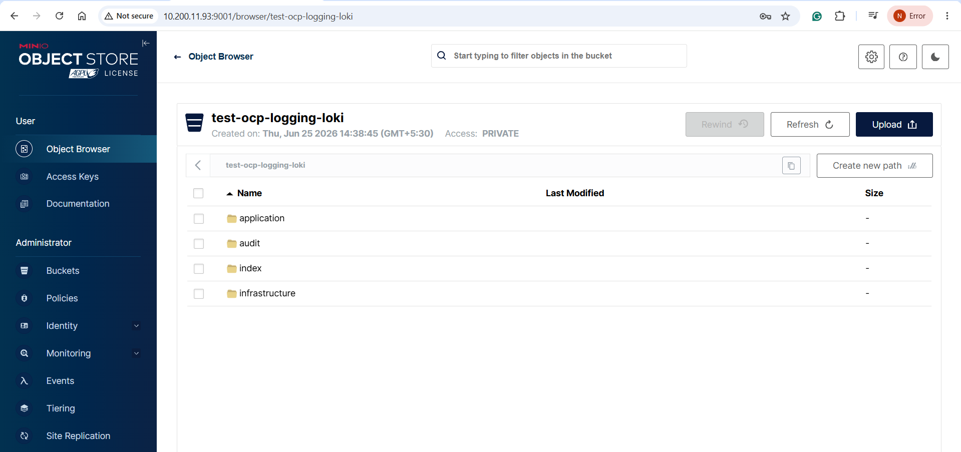
#

Worked-session style secret, using the name actually used during migration:
apiVersion: v1
kind: Secret
metadata:
name: logging-loki-s3
namespace: openshift-logging
type: Opaque
stringData:
access_key_id: <access_key_id>
access_key_secret: <secret_access_key>
bucketnames: <bucket_name>
endpoint: https://<minio_or_s3_endpoint>
region: <region_or_placeholder>
forcepathstyle: "true"
MinIO-specific alternative, following Red Hat’s nomenclature:
oc -n openshift-logging create secret generic logging-loki-minio \
--from-literal=bucketnames="<bucket_name>" \
--from-literal=endpoint="<minio_bucket_endpoint>" \
--from-literal=access_key_id="<minio_access_key_id>" \
--from-literal=access_key_secret="<minio_access_key_secret>" \
--from-literal=forcepathstyle="true"
Expected output and check. oc get secret -n openshift-logging should show the created secret. If endpoint style is wrong for the target object store, ingesters may fail later during flush or compaction. [15]

Create the LokiStack
The install guide’s LokiStack example uses name: logging-loki, namespace: openshift-logging, managementState: Managed, a retention block, a size, a storage schema, and a storage secret reference. Red Hat’s current example uses schema v13. [10]
A production-leaning baseline manifest is:
apiVersion: loki.grafana.com/v1
kind: LokiStack
metadata:
name: logging-loki
namespace: openshift-logging
spec:
managementState: Managed
limits:
global:
retention:
days: 20
size: 1x.small
storage:
schemas:
- version: v13
effectiveDate: "2026-06-25"
secret:
name: logging-loki-s3
type: s3
storageClassName: <storage_class_name>
tenants:
mode: openshift-logging
In the worked session, the final validated size was effectively reduced to 1x.demo because a second ingester could not schedule after placement was moved to infra nodes and insufficient free memory remained available. That was a pragmatic validation choice, not a production recommendation.
oc apply -f lokistack.yaml
oc get lokistack logging-loki -n openshift-logging
oc describe lokistack logging-loki -n openshift-logging
oc get pods -n openshift-logging | grep -i loki
oc get pvc -n openshift-logging | grep -i loki
Expected output and check. oc describe lokistack should eventually show Ready=True or otherwise indicate that all components are ready. Pod inventory should include gateway, distributor, querier, query-frontend, compactor, index-gateway, and one or more ingesters.

Patch Loki placement when node roles and taints require it
Red Hat documents that Loki pod placement can be controlled with selectors and tolerations. That capability was essential in the worked session because both worker capacity and infra taints blocked scheduling at different times. [9]
The session used this ingester patch to move scheduling to infra nodes:
oc patch lokistack logging-loki -n openshift-logging --type=json -p='[
{
"op": "replace",
"path": "/spec/template/ingester/nodeSelector",
"value": {
"node-role.kubernetes.io/infra": ""
}
},
{
"op": "replace",
"path": "/spec/template/ingester/tolerations",
"value": [
{
"key": "node-role.kubernetes.io/infra",
"operator": "Equal",
"value": "reserved",
"effect": "NoSchedule"
},
{
"key": "node-role.kubernetes.io/infra",
"operator": "Equal",
"value": "reserved",
"effect": "NoExecute"
}
]
}
]'
oc describe pod logging-loki-ingester-1 -n openshift-logging
oc adm top nodes
Expected output and check. If Pending persists after this patch, the scheduler events usually reveal the real reason: Insufficient cpu, Insufficient memory, or selector/taint mismatch. In the worked session, the failure mode moved from CPU shortage on workers to memory shortage on infra after placement had been corrected.

Install the Red Hat OpenShift Logging Operator
Red Hat’s install guide states that the Logging Operator manages collection and forwarding and must be installed after Loki. The operator package and channel are controlled by the release in use, so the exact subscription object should be confirmed against the cluster catalogue if installed by CLI rather than OperatorHub. The key principle from the documentation is that Logging and Loki must use the same major and minor version. [16]
Representative verification commands are:
oc get subscription -A | grep -i logging
oc get csv -n openshift-logging
oc get deploy -n openshift-logging
Expected output and check. The Logging Operator CSV should reach Succeeded, and the cluster logging operator deployment should become available.
apiVersion: observability.openshift.io/v1
kind: ClusterLogForwarder
metadata:
name: collector
namespace: openshift-logging
spec:
managementState: Managed
serviceAccount:
name: logcollector
outputs:
- name: lokistack
type: lokiStack
lokiStack:
target:
name: logging-loki
namespace: openshift-logging
authentication:
token:
from: serviceAccount
tls:
ca:
configMapName: logging-loki-gateway-ca-bundle
key: service-ca.crt
pipelines:
- name: logs-to-loki
inputRefs:
- application
- infrastructure
- audit
outputRefs:
- lokistack

oc apply -f clf.yaml
oc describe clusterlogforwarder collector -n openshift-logging
oc get clusterlogforwarder collector -n openshift-logging -o yaml
Expected output and check. The live YAML must show outputs[].tls.ca, not outputs[].lokiStack.tls. Readiness should become Ready=True. Red Hat’s own example for LokiStack output with a service-account token and output-level TLS is the correct schema reference. [18]

oc get clusterrole | grep -E \
'collect-application-logs|collect-infrastructure-logs|collect-audit-logs|logging-collector-logs-writer'

oc adm policy add-cluster-role-to-user collect-application-logs \
system:serviceaccount:openshift-logging:logcollector

oc adm policy add-cluster-role-to-user collect-infrastructure-logs \
system:serviceaccount:openshift-logging:logcollector

oc adm policy add-cluster-role-to-user collect-audit-logs \
system:serviceaccount:openshift-logging:logcollector

oc adm policy add-cluster-role-to-user logging-collector-logs-writer \
system:serviceaccount:openshift-logging:logcollector
If the collector DaemonSet hits immutable selector errors during migration from older resources, the worked-session fix was to delete the operator-managed DaemonSet and let the operator recreate it.
oc delete ds collector -n openshift-logging
oc get pods -n openshift-logging | grep collector
Then create the UI plugin:
apiVersion: observability.openshift.io/v1alpha1
kind: UIPlugin
metadata:
name: logging
spec:
type: Logging
logging:
lokiStack:
name: logging-loki
logsLimit: 50
timeout: 30s
schema: viaq
oc apply -f uiplugin-logging.yaml
oc get uiplugin
oc get consoleplugin
Enable the console plugin:
oc patch consoles.operator.openshift.io cluster \
--type merge \
-p '{"spec":{"plugins":["monitoring-plugin","networking-console-plugin","logging-view-plugin"]}}'
oc get consoles.operator.openshift.io cluster -o yaml | grep -A10 plugins
oc get co console
Expected output and check. logging-view-plugin should appear in oc get consoleplugin, and the OpenShift Console should show Observe > Logs after refresh or re-login. Red Hat also notes that GitOps-managed Console resources can remove the plugin unless it is declared in Git-managed console configuration. [20]

Verification and operational checks
Verification has two dimensions: resource health and functional visibility. Resource health confirms that operators, CRs, and pods are reconciled and Running. Functional visibility proves that a fresh log written by a workload is visible in Observe > Logs.
A good baseline inventory command set is:
oc get subscription -A | egrep 'loki|logging|observability'
oc get csv -A | egrep 'loki|logging|observability'
oc get lokistack logging-loki -n openshift-logging -o yaml
oc get clusterlogforwarder collector -n openshift-logging -o yaml
oc get uiplugin -A
oc get consoleplugin
oc get pods -n openshift-logging | egrep 'collector|loki'
oc get pvc -n openshift-logging | grep loki
Expected output and check. Operator CSVs should be Succeeded; the LokiStack should be Ready; the ClusterLogForwarder should show Authorized=True, Valid=True, and Ready=True; collectors should be Running on the intended nodes; and the UIPlugin plus console plugin should be present.
The best functional validation is a new workload that emits deterministic logs after collectors and Loki pods are healthy:
oc new-project log-test
oc run loki-test \
--image=registry.access.redhat.com/ubi9/ubi \
--restart=Never \
-- /bin/bash -c 'for i in {1..200}; do echo "loki migration test log $i"; sleep 2; done'
oc logs loki-test -n log-test
In the console, check:
- Observe > Logs
- Time range: Last 30 minutes
- Log type: application
- Namespace: log-test
- Search string: loki migration test log
This validation pattern mirrors the successful session outcome.
The component model is easier to operate if responsibilities are documented clearly.
Component | Example pod name | Example PVC name | Stateful | Purpose
Collector | collector-xxxxx | None; host-path log access on nodes | No | Reads container/node logs and forwards them
Gateway | logging-loki-gateway-xxxxx | None | No | Entry point, authentication, TLS, tenant routing
Distributor | logging-loki-distributor-xxxxx | None | No | Validates streams, enforces limits, forwards to ingesters
Ingester | logging-loki-ingester-0 | storage-logging-loki-ingester-0, wal-logging-loki-ingester-0 | Yes | Buffers, WAL-writes, chunks, flushes to object storage
Index gateway | logging-loki-index-gateway-0 | Profile-dependent; verify with oc get pvc | Usually yes | Serves metadata and chunk reference lookups
Compactor | logging-loki-compactor-0 | storage-logging-loki-compactor-0 or equivalent, depending on profile | Yes | Compacts indexes, enforces retention and deletion
Querier | logging-loki-querier-xxxxx | None | No | Executes queries against ingesters and object storage
Query frontend | logging-loki-query-frontend-xxxxx | None | No | Queues, splits, caches, and aggregates queries
The Ingester’s WAL deserves special emphasis. Grafana explains that ingesters temporarily store data in memory and that the WAL records incoming data on local filesystem so that acknowledged writes can be replayed after a crash. That is precisely why ingesters need PVC-backed local state even when object storage is the durable system of record. Grafana also notes that if the WAL disk fills, Loki will continue accepting writes but will not achieve the expected persistence guarantees across a restart. [21]
MinIO, or any other S3-compatible backend, is therefore not a replacement for the ingester PVCs; it is the long-term object storage backend where chunks and index data are persisted after flush. Grafana’s storage documentation and Red Hat’s object storage chapter both support this split model: Loki’s single-store architecture uses object storage for both data chunks and index data, with TSDB recommended in modern versions. [22]

Troubleshooting and rollback
The worked session makes it clear that Loki-on-OCP troubleshooting is primarily about identifying which layer of the path is failing: scheduling, TLS trust, operator reconciliation, or Loki data validation. The most common issues and their fixes are summarised below.
Symptom | Primary cause | Corrective action | Core commands
COO install timeout | Pending pods caused by worker CPU shortage and untolerated infra taints | Patch the subscription and deployments with infra nodeSelector and tolerations | oc get pods -n openshift-cluster-observability-operator; oc describe pod <pending-pod>
Ingester Pending | Insufficient CPU or memory, or wrong selector/taint combination | Patch LokiStack placement or reduce profile size temporarily | oc describe pod logging-loki-ingester-1 -n openshift-logging; oc adm top nodes
Collector TLS error such as self-signed CA failure | Collector does not trust Loki gateway service certificate | Inject and reference service CA bundle under outputs[].tls.ca | oc get cm openshift-service-ca.crt -n openshift-logging -o yaml; oc get clf collector -o yaml
CLF applied but no tls in live spec | Wrong schema path such as lokiStack.tls | Move tls to the output level as a sibling of type and lokiStack | oc get clusterlogforwarder collector -o yaml
400 Bad Request from Loki | Invalid or stale records, commonly old timestamps | Start with application logs only; inspect distributor logs | oc logs -n openshift-logging -l app.kubernetes.io/component=distributor
429 Too Many Requests or rate-limit errors | Tenant ingestion exceeded configured limits | Increase Loki limits or reduce initial scope, especially for audit logs | oc logs collector-*; oc logs distributor-*
500 Internal Server Error on writes | Backend not fully healthy, insufficient ingester capacity, or quorum issue | Ensure LokiStack readiness, inspect gateway/distributor/ingester logs | oc describe lokistack logging-loki -n openshift-logging
Collector DaemonSet immutable selector | Migration collision with existing operator-managed DS | Delete ds/collector and let the operator recreate it | oc delete ds collector -n openshift-logging
Observe page visible but no logs | Either no readable ingested data or incorrect filter scope | Generate fresh application logs and filter on the correct namespace/time range | oc run loki-test ...; use Observe > Logs
Several official Red Hat and Grafana references are directly relevant to these failures. Red Hat documents that service-account permissions must be granted explicitly for logging 6, that Loki routing can be rate limited and tuned through ingestionBurstSize and ingestionRate, and that Loki pod placement can be controlled through selectors and tolerations. Grafana documents that the distributor validates labels, timestamps, and tenant limits, while the ingester handles WAL-backed persistence and flushes to object storage. [23]
The most instructive lesson from the session was this: forwarding all streams too early made the system look broken even after TLS and UI were fixed. Audit log bursts and stale infrastructure timestamps caused Loki-side errors, while application logs were perfectly valid. As a result, the fastest route to proving the architecture was to narrow the ClusterLogForwarder to application logs only, validate end-to-end success, and then tune infrastructure and audit ingestion deliberately afterwards. That is also the safest production migration method.
Rollback planning in Logging 6 should be conservative. Red Hat’s upgrade guidance explicitly recommends a staged migration from the old Elastic-based stack and makes it clear that old resources are deleted only after the new flow is validated. In practice, that means not uninstalling Elasticsearch and Kibana, and not deleting legacy CRDs, until Loki ingestion and UI access have been signed off. [2]
A safe rollback sequence is:
oc patch consoles.operator.openshift.io cluster \
--type merge \
-p '{"spec":{"plugins":["monitoring-plugin","networking-console-plugin"]}}'
oc delete uiplugin logging
Then either restore the previous log destination or suspend Loki forwarding by reapplying the previous known-good ClusterLogForwarder. If the migration started from a managed Elastic/Kibana stack, only revert ownership and management state if those resources were preserved intentionally. This is why the old stack should remain intact until business validation is complete.

DOCX build instructions and appendices
The requested deliverable is a Word-document SOP structure, not an attachment. The recommended build method is to store this report in source control as Markdown or plain text and generate a .docx by using python-docx. That approach is reproducible, auditable, and easy to automate in a CI or GitOps-adjacent documentation pipeline.
The document structure should be:
Section order | Document element
Front matter | Title page
Front matter | Table of contents
Core text | Executive summary
Core text | Architecture and prerequisites
Core text | Step-by-step SOP
Core text | Verification and operational checks
Core text | Troubleshooting and rollback
Appendix | Manifest appendix
Appendix | Verification checklist
Appendix | Production hardening checklist
A minimal generation workflow is:
python3 -m venv .venv
source .venv/bin/activate
pip install python-docx
python build_loki_sop.py
A minimal build_loki_sop.py skeleton is:
from docx import Document
doc = Document()
doc.add_heading("Standard Operating Procedure", level=0)
doc.add_paragraph("Loki on OpenShift Container Platform")
doc.add_page_break()
doc.add_heading("Table of contents", level=1)
doc.add_paragraph("Update this field inside Microsoft Word after opening the file.")
doc.add_page_break()
doc.add_heading("Executive summary", level=1)
doc.add_paragraph("Paste the executive summary here.")
doc.add_heading("Architecture and prerequisites", level=1)
doc.add_paragraph("Paste the architecture section here.")
doc.add_heading("Step-by-step SOP", level=1)
doc.add_paragraph("Paste the detailed procedure here.")
doc.add_heading("Verification and operational checks", level=1)
doc.add_paragraph("Paste the verification section here.")
doc.add_heading("Troubleshooting and rollback", level=1)
doc.add_paragraph("Paste the troubleshooting section here.")
doc.add_heading("Appendices", level=1)
doc.add_paragraph("Paste manifests, checklists, and diagrams here.")
doc.save("Loki_on_OCP_Comprehensive_SOP.docx")
If Mermaid diagrams must be rendered as images before insertion into Word, use a Mermaid renderer such as mmdc during the document build stage, then insert the exported PNG or SVG into the .docx. If the document is intended mainly for internal engineering use, it is often simpler to keep the Mermaid source as fenced code blocks in the appendix and maintain an HTML or Markdown version for rendered viewing.
The following appendix-ready manifests and commands should be kept as separate source files in version control:
- loki-operator.yaml
- logging-namespace.yaml
- logging-loki-s3-secret.yaml
- lokistack.yaml
- lokistack-placement-patch.sh
- rbac-logcollector.sh
- clf-app-only.yaml
- clf-all-streams.yaml
- coo-subscription.yaml
- coo-infra-patch.sh
- uiplugin-logging.yaml
- console-enable-logging-plugin.sh
- verification-checks.sh
A production hardening checklist for the .docx appendix should include the following items:
Hardening item | Recommendation
Availability | Use a supported production size such as 1x.extra-small, 1x.small, or 1x.medium; do not leave production on 1x.demo
Capacity planning | Allocate CPU, memory, and PVC capacity for both Loki and COO before enabling all streams
Retention | Configure Loki retention and bucket lifecycle policy intentionally
Node placement | Define selectors, tolerations, and topology strategy explicitly
Storage resilience | Use managed S3-compatible storage or supported ODF object storage with backup and lifecycle controls
Monitoring | Alert on WAL corruption, WAL disk fullness, object store failures, Pending pods, and distributor rate limiting
Ingestion scope | Validate application logs first; enable infrastructure and audit only after rate-limit and timestamp strategy are understood
Rollback | Preserve Elasticsearch/Kibana and migration-era manifests until sign-off is complete
Change control | Store all manifests, patches, and generated SOPs in source control with version tags
Finally, this SOP should record two explicit caveats from the migration session. First, chat logs from the 25 June 2026 session were used as source material for the implementation examples and corrective patches. Secondly, where cluster-specific information such as node count, exact storage class, actual bucket endpoint, or final operator channel values was not universally known from the session or from the official documentation, those fields have been marked as unspecified and should be completed during environment-specific implementation.

[1] [2] [5] [7] https://docs.redhat.com/en/documentation/red_hat_openshift_logging/6.3/html/upgrading_logging/upgrading-to-logging-6
https://docs.redhat.com/en/documentation/red_hat_openshift_logging/6.3/html/upgrading_logging/upgrading-to-logging-6
[3] [4] [8] [9] [11] [15] [17] [18] [23] Configuring logging | Red Hat OpenShift Logging | 6.3 | Red Hat Documentation
https://docs.redhat.com/en/documentation/red_hat_openshift_logging/6.3/html-single/configuring_logging/index
[6] [10] [12] [13] [14] [16] https://docs.redhat.com/en/documentation/red_hat_openshift_logging/6.3/html/installing_logging/installing-logging
https://docs.redhat.com/en/documentation/red_hat_openshift_logging/6.3/html/installing_logging/installing-logging
[19] [20] https://docs.redhat.com/en/documentation/red_hat_openshift_cluster_observability_operator/1-latest/html/ui_plugins_for_red_hat_openshift_cluster_observability_operator/logging-ui-plugin
https://docs.redhat.com/en/documentation/red_hat_openshift_cluster_observability_operator/1-latest/html/ui_plugins_for_red_hat_openshift_cluster_observability_operator/logging-ui-plugin
[21] https://grafana.com/docs/loki/latest/operations/storage/wal/
https://grafana.com/docs/loki/latest/operations/storage/wal/
[22] https://grafana.com/docs/loki/latest/configure/storage/
https://grafana.com/docs/loki/latest/configure/storage/

